Dog Breed Identification using transfer learning

Project Description:
Dog breed identification using transfer learning is a deep learning project that focuses on classifying different dog breeds from digital images. The main goal of this system is to automatically recognize the breed of a dog by analyzing visual features such as shape, fur pattern, ear structure, and facial characteristics. Instead of building a neural network model from scratch, this project uses transfer learning, which allows a pre-trained convolutional neural network to be adapted for a new task. By leveraging existing knowledge learned from large image datasets, the model can accurately identify dog breeds even when trained on a comparatively smaller dataset.

Transfer learning plays a crucial role in improving the efficiency and performance of the model. Pre-trained architectures such as VGG, ResNet, MobileNet, and Inception are commonly used because they have already learned rich feature representations from millions of images. In this project, the earlier layers of the network are usually frozen to retain general image features, while the final layers are modified and trained specifically for dog breed classification. This approach reduces computational cost, minimizes training time, and improves accuracy. Additionally, data preprocessing techniques such as image resizing, normalization, and augmentation help enhance model generalization.

The project typically involves several stages, including dataset preparation, model selection, training, evaluation, and prediction. A labeled dataset containing images of various dog breeds is divided into training and testing sets. After training the customized model, its performance is evaluated using metrics such as accuracy and loss. A confusion matrix may also be used to analyze classification performance across breeds. Once deployed, the system can accept a new dog image as input and predict its breed along with a confidence score. This project demonstrates the practical application of artificial intelligence in animal recognition and automated image classification systems.

Technical Architecture:
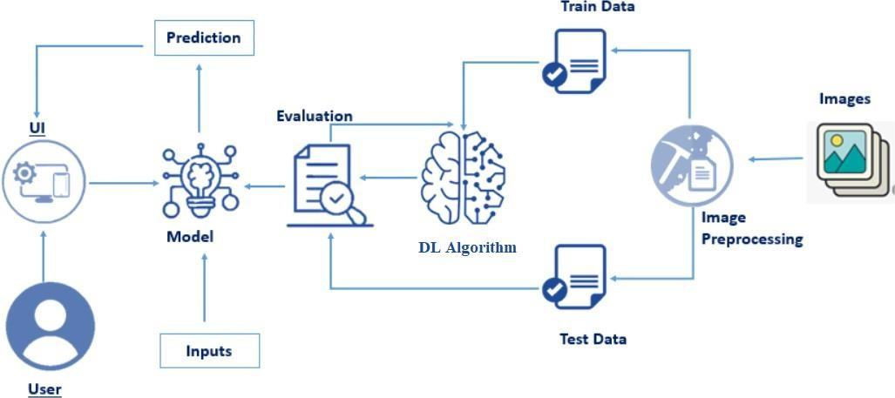

Pre requisites:
To complete this project, you must required following software’s, concepts and packages
- Anaconda navigator and pycharm:
  - Refer the link below to download anaconda navigator
  - Link: https://youtu.be/1ra4zH2G4o0
- Python packages:
- open anaconda prompt as administrator
- Type “pip install numpy” and click enter.
- Type “pip install pandas” and click enter.
- Type “pip install scikit-learn” and click enter.
- Type “pip install tensorflow==2.12.0” and click enter.
- Type “pip install keras==2.12.0” and click enter.
- Type “pip install Flask” and click enter.

Prior Knowledge:
You must have prior knowledge of following topics to complete this project.
- Deep Learning Concepts
  - CNN: https://youtu.be/OD_7Vn4ITNs?si=JfhKrJvc1YXx1PET
  - VGG19: https://youtu.be/V_O9QtVg8bY?si=Psa8l4n7_DtTgpDu
  - Flask: https://youtu.be/lj4I_CvBnt0?si=cf-G0uw5iIof8d82

Project Objectives:
By the end of this projec you will:
- Know fundamental concepts and techniques of Convolutional Neural Network.
- Gain a broad understanding of image data.
- Know how to pre-process/clean the data using different data preprocessing techniques.
- know how to build a web application using the Flask framework.

Project Flow:
- The user interacts with the UI (User Interface) to choose the image.
- The chosen image is analyzed by the model which is integrated with flask application.
- CNN Models analyze the image, then prediction is showcased on the Flask UI. To accomplish this, we must complete all the activities and tasks listed below.
To accomplish this, we have to complete all the activities listed below,
- Data collection
  - Create Train and Test Folders.
- Data Preprocessing.
  - Import the ImageDataGenerator library
  - Configure ImageDataGenerator class
  - ApplyImageDataGenerator functionality to Train dataset and Test dataset
- Model Building
  - Import the model building Libraries.
  - Importing the VGG19.
  - Initializing the model
  - Adding Fully connected Layer
  - Configure the Learning Process
  - Training and Testing the model.
  - Save the Model

- Application Building
  - Create an HTML file
  - Build Python Code

Project Structure:
Create the Project folder which contains files as shown below
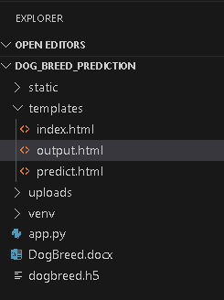
- We are building a Flask Application that needs HTML pages stored in the templates.
- folder and a python script app.py for server-side scripting
- we need the model which is saved and the saved model in this content is a dogbreed.h5
- templates folder contains index.html, predict.html & output.html pages.
- The Static folder contains css file, images.

Milestone 1: Data Collection
In this milestone, dog breed images are collected and organized into separate subdirectories based on their breed names according to the project structure. Folders are created for each breed that needs to be recognized by the model. The project includes 20 different dog breeds such as Affenpinscher, Beagle, Boxer, German Shepherd, Golden Retriever, Pug, and others. All images are stored in their respective breed folders to ensure proper labeling and smooth model training.
In Image Processing, we will be improving the image data that suppresses unwilling distortions or enhances some image features important for further processing, although perform some geometric transformations of images like rotation, scaling, translation, etc.

Activity 1: Download the dataset
There are many popular open sources for collecting the data. Eg: kaggle.com, UCI repository, etc.
This data is downloaded from kaggle.com. Please refer to the link given below to download the dataset.
Link: - https://www.kaggle.com/competitions/dog-breed-identification/data?select=train
Activity 2: Create Train and Test Folders
Create two main folders named Train and Test.
Inside each folder, create subfolders for every dog breed and arrange the images accordingly.
Generally, 70–80% of images are placed in Train and 20–30% in Test for proper model training and evaluation.
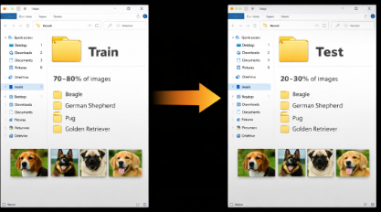
Milestone 2: Data Preprocessing.
Data preprocessing involves resizing all dog images to a fixed size (such as 224×224 pixels) and normalizing pixel values to improve model performance.
It also includes data augmentation techniques like rotation, flipping, and zooming to increase dataset diversity and reduce overfitting.

Activity 1: Organizing the Images into Different Classes.
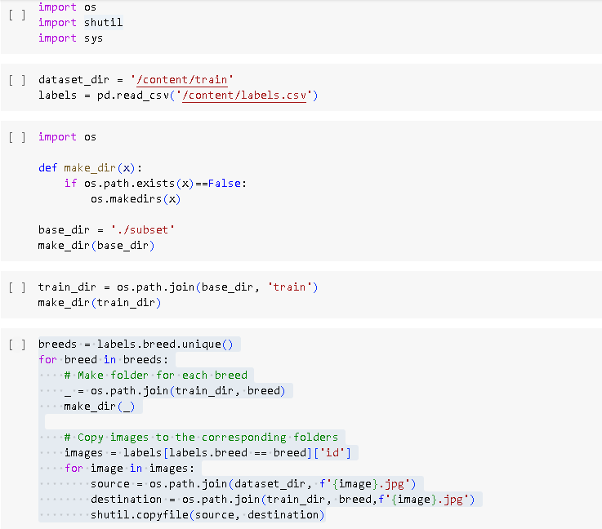
The Images should be organized based on the Image id’s. So that Training the Model will be simpler. For each image ID (image_id) in the current breed, the source path is formed by combining the dataset_dir and the image filename (f'{image_id}.jpg'). The destination path is formed by combining the breed_folder and the same image filename. shutil.copyfile() is used to copy the image from the source path to the destination path.
shutil.copyfile() is a Python function that copies the contents of one file to another specified destination file path.
Activity 2: Import the ImageDataGenerator library.
Image data augmentation is a technique that can be used to artificially expand the size of a training dataset by creating modified versions of images in the dataset.
The Keras deep learning neural network library provides the capability to fit models using image data augmentation via the ImageDataGenerator class.Let us import the ImageDataGenerator class from tensorflow Keras.
Activity 3: Configure ImageDataGenerator class
ImageDataGenerator class is instantiated and the configuration for the types of data augmentation. There are five main types of data augmentation techniques for image data; specifically:
- Image shifts via the width_shift_range and height_shift_range arguments.
- The image flips via the horizontal_flip and vertical_flip arguments.
- Image rotations via the rotation_range argument
- Image brightness via the brightness_range argument.
- Image zoom via the zoom_range argument.
An instance of the ImageDataGenerator class can be constructed for train and test.
Activity 4: Apply ImageDataGenerator functionality to Trainset and Test set
Let us apply ImageDataGenerator functionality to Train set and Test set by using the following code. For Training set using flow_from_directory function.
This function will return batches of images from the subdirectories affenpinscher, beagle, appenzeller, basset, bluetick, boxer, cairn, doberman, german_shepherd, golden_retriever, kelpie, komondor, leonberg, mexican_hairless, pug, redbone, shih-tzu, toy_poodle, vizsla, whippe, together with labels 0 to 19.
Arguments:
- directory: Directory where the data is located. If labels are "inferred", it should contain subdirectories, each containing images for a class. Otherwise, the directory structure is ignored.
- batch_size: Size of the batches of data which is 32.
- target_size: Size to resize images after they are read from disk.
- class_mode:
‘int': means that the labels are encoded as integers (e.g. for sparse_categorical_crossentropy loss).
'categorical' means that the labels are encoded as a categorical vector (e.g. for categorical_crossentropy loss).
- 'binary' means that the labels (there can be only 2) are encoded as float32 scalars with values 0 or 1 (e.g. for binary_crossentropy).
- None (no labels).
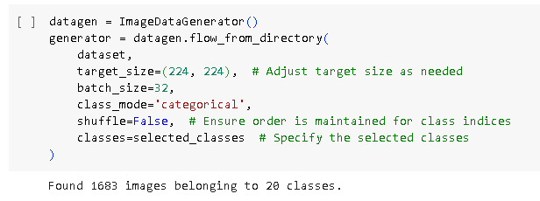
We notice that 1683 images belong to 20 classes for training purposes.

Milestone 3: Model Building
Now our data is preprocessed and ready, so the next step is to build the model. For this Dog Breed Identification project, we use transfer learning with the VGG19 architecture to perform image classification. The best model is saved based on its performance and accuracy after evaluation.
Activity 1: Importing the Model Building Libraries
Importing the model building libraries is the first step in developing the dog breed identification system. Tensor Flow and Keras are used for model development, while ImageDataGenerator helps in image preprocessing and augmentation. Dense layers and activation functions like softmax are imported to design the fully connected classification layers and configure the output predictions.
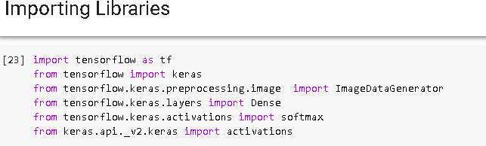

Activity 2: Importing the VGG19 model
To initialize the VGG19 model, the weights are usually pre-trained on the ImageNet dataset, which is a large-scale dataset of images belonging to 1,000 different categories. These pre-trained weights can be downloaded from the internet, and they can be used as a starting point to fine-tune the model for a specific task, such as object recognition or classification.
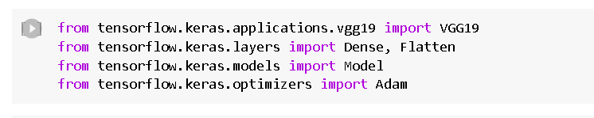
Activity 3: Initializing the model
- The model will be initialized with the pre-trained weights from the ImageNet dataset, and the last fully connected layer will be excluded from the model architecture.
- The loop that follows freezes the weights of all the layers in the VGG19 model by setting`i.trainable=False` for each layer in the model. This is done to prevent the weights from being updated during training, as the model is already pre-trained on a large dataset.
- Finally, a `Flatten()` layer is added to the output of the VGG19 model to convert the output tensor into a 1D tensor.
- The resulting model can be used as a feature extractor for transfer learning or as a starting point for building a new model on top of it.
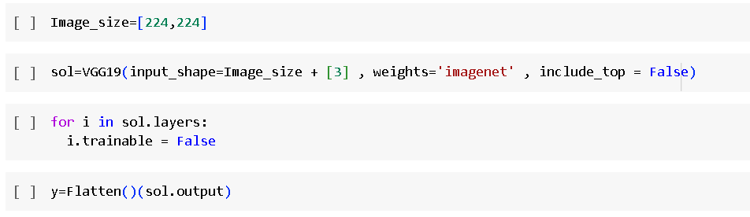
Flatten() is a Keras layer that converts multi-dimensional feature maps into a one-dimensional vector before passing them to fully connected layers.
Activity 4: Adding Fully connected Layers
- For information regarding CNN Layers refer to the link Link: https://victorzhou.com/blog/intro-to-cnns-part-1/
- As the input image contains three channels, we are specifying the input shape as (128,128,3).
- We are adding a output layer with activation function as “softmax”.
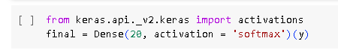
A dense layer is a deeply connected neural network layer. It is the most common and frequently used layer. The number of neurons in the Dense layer is the same as the number of classes in the training set. The neurons in the last De nse layer, use softmax activation to convert their outputs into respective probabilities.
Understanding the model is a very important phase to properly use it for training and prediction purposes. Keras provides a simple method, summary to get the full information about the model and its layers.
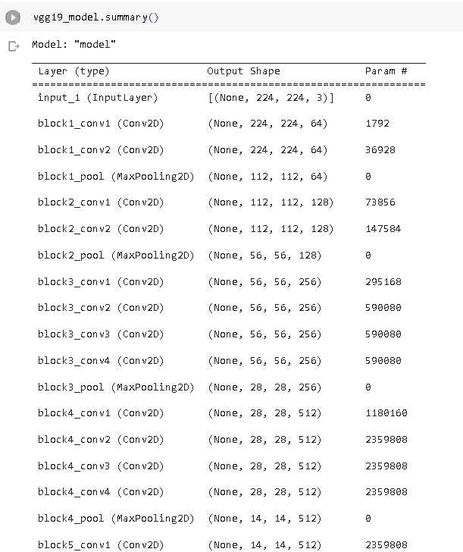

Activity 5: Configure The Learning Process.
- The compilation is the final step in creating a model. Once the compilation is done, we can move on to the training phase. The loss function is used to find errors or deviations inthe learning process. Keras requires a loss function during the model compilation process.
- Optimization is an important process that optimizes the input weights by comparing the prediction and the loss function. Here we are using adam optimizer.
- Metrics are used to evaluate the performance of your model. It is similar to the loss function, but not used in the training process.

Activity 6: Train The model
Now, let us train our model with our image dataset. The model is trained for 6 epochs and after every epoch, the current model state is saved if the model has the least loss encountered till that time. We can see that the training loss decreases in almost every epoch till 30 epochs and probably there is further scope to improve the model.fit_generator functions used to train a deep learning neural network.

steps_per_epoch: it specifies the total number of steps taken from the generator as soon as one epoch is finished and the next epoch has started. We can calculate the value of steps_per_epoch as the total number of samples in your dataset divided by the batch size.

Epochs: an integer and number of epochs we want to train our model for.

validation_data can be either:

an inputs and targets list

a generator

an inputs, targets, and sample_weights list which can be used to evaluate the loss and metrics for any model after any epoch has ended.

validation_steps: only if the validation_data is a generator then only this argument can be used. It specifies the total number of steps taken from the generator before it isstopped at every epoch and its value is calculated as the total number of validation data points in your dataset divided by the validation batch size.

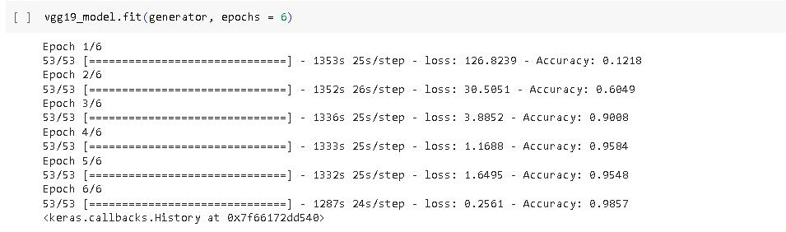
Activity7: Save the Model
The model is saved with .h5 extension as follows.
An H5 file is a data file saved in the Hierarchical Data Format (HDF). It contains multidimensional arrays of scientific data.
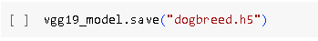
Activity8: Test The model
Evaluation is a process during the development of the model to check whether the model is the best fit for the given problem and corresponding data.
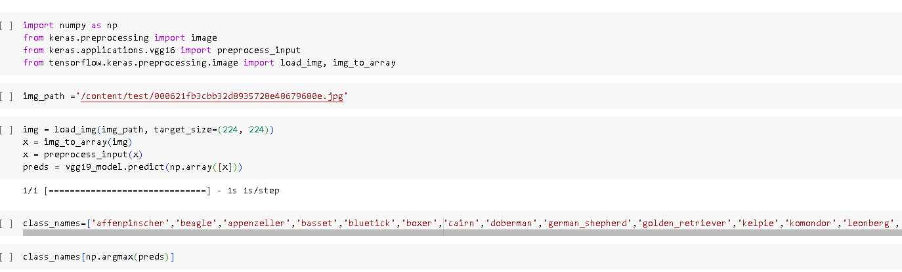
Taking an image as input and checking the results
By using the model we are predicting the output for the given input image. The predicted class index name will be printed here.
Milestone 4: Application Building
Activity1: Create HTML Pages
- We use HTML to create the front end part of the web page.
- Here, we have created 3 HTML pages- index.html, predict.html, and output.html
- home.html displays the home page.
- index.html displays an introduction about the project
- upload.html gives the emergency alert For more information regarding HTML https://www.w3schools.com/html/
- We also use JavaScript-main.js and CSS-main.css to enhance our functionality and view of HTML pages.
- Link :CSS , JSindex.html looks like this

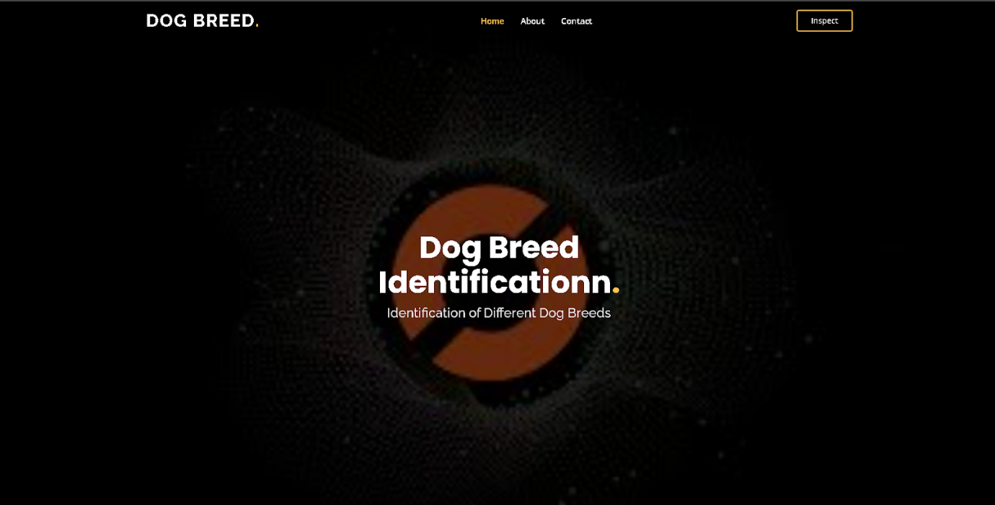
About Section:-
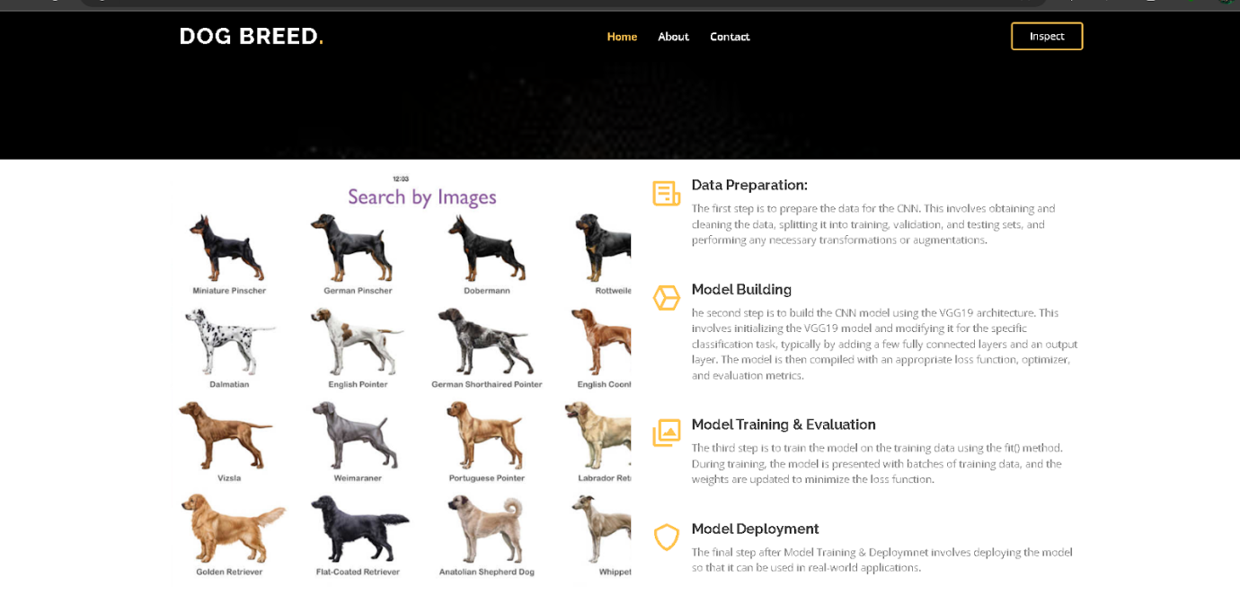
- page.
- Here, we have created 3 HTML pages- index.html, predict.html, and output.html
- home.html displays the home page.
- index.html displays an introduction about the project
- upload.html gives the emergency alert For more information regarding HTML https://www.w3schools.com/html/
- We also use JavaScript-main.js and CSS-main.css to enhance our functionality and view of HTML pages.
Link: CSS , JS, index.html looks like this
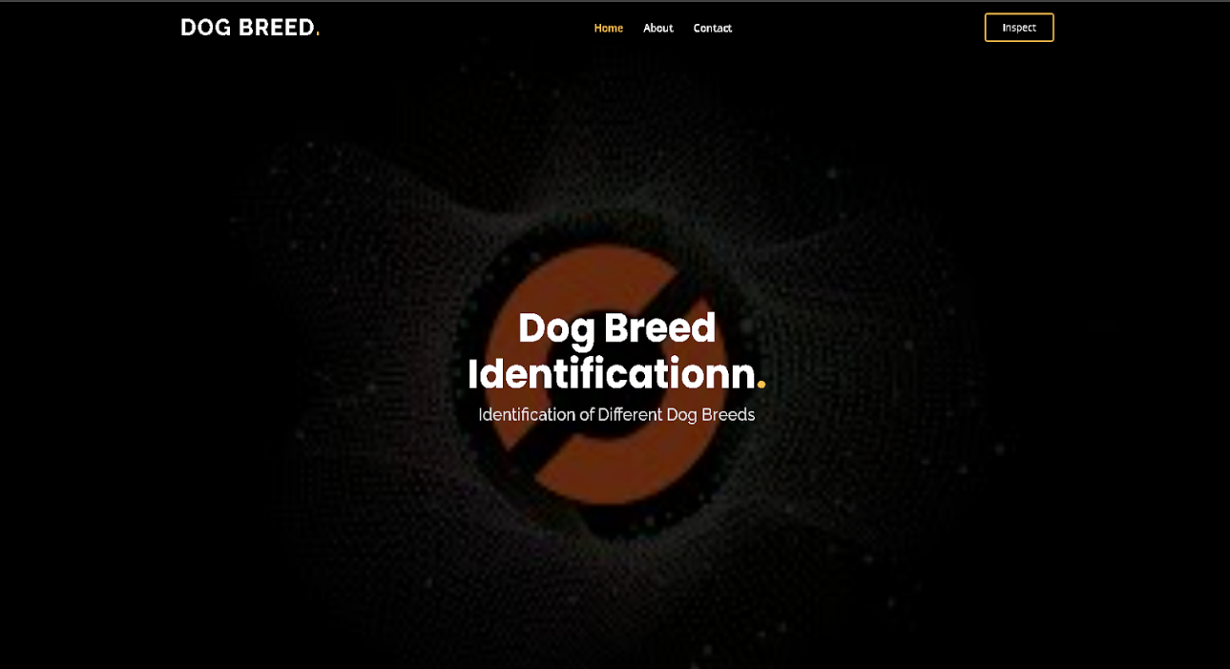

About Section:-
Contact Us :
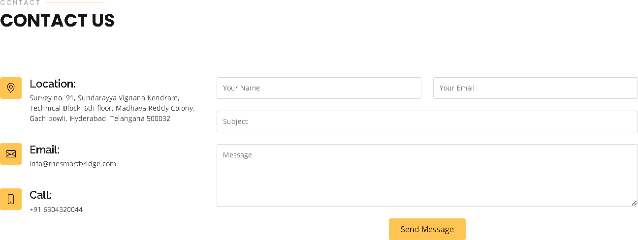
Activity 2: Build python code
- In the application building phase, Python code is written to load the saved trained model using TensorFlow or Keras.
- The input dog image is preprocessed by resizing, converting to an array, and normalizing pixel values.
- The model predicts the dog breed by passing the processed image through the network.
- Finally, the predicted breed name and confidence score are displayed as the output of the application.
Activity 3: Importing Libraries
The first step is usually importing the libraries that will be needed in the program.
Importing the flask module in the project is mandatory. An object of the Flask class is our WSGI application. Flask constructor takes the name of the current module ( name ) as argument Pickle library to load the model file.
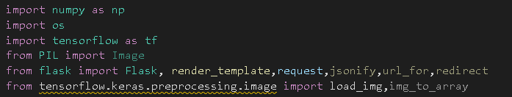
Activity 4: Creating our flask application and loading our model by using load_model method
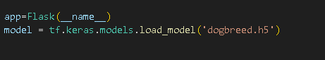
In this step, a Flask application is created to deploy the Dog Breed Identification model as a web application. The saved trained model is loaded using the load_model() method from Keras, which allows the application to use the trained weights for prediction. Flask handles user requests, such as uploading a dog image through the web interface. Once the image is received, it is preprocessed and passed to the loaded model for classification. The predicted dog breed and confidence score are then displayed on the web page as the final output.
Activity 5: Routing to the html Page
Here, the declared constructor is used to route to the HTML page created earlier.
In the above example, ‘/’ URL is bound with index.html function. Hence, when the home page of a web server is opened in the browser, the html page will be rendered. Whenever you browse an image from the html page this photo can be accessed through POST or GET Method.
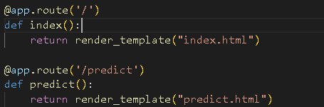
Showcasing prediction on UI:
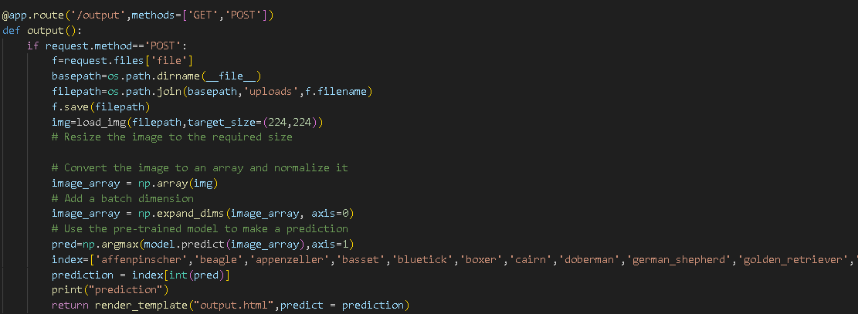
Here we are defining a function which requests the browsed file from the html page using the post method. The requested picture file is then saved to the uploads folder in this same directory using OS library. Using the load image class from Keras library we are retrieving the saved picture from the path declared. We are applying some image processing techniques and then sending that preprocessed image to the model for predicting the class. This returns the numerical value of a class (like 0 to 19.) which lies in the 0th index of the variable preds. This numerical value is passed to the index variable declared. This returns the name of the class. This name is rendered to the prediction variable used in the html page.Finally, Run the application. This is used to run the application in a local host.
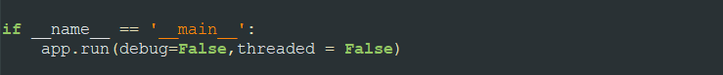
Activity 6: Run the application
- Open the anaconda prompt from the start menu.
- Navigate to the folder where your app.py resides.
- Now type “python app.py” command.
- It will show the local host where your app is running on http://127.0.0.1.5000/
- Copy that local host URL and open that URL in the browser. It does navigate me to where you can view your web page.
- Enter the values, click on the predict button and see the result/prediction on the web page.
Then it will run on localhost: 5000
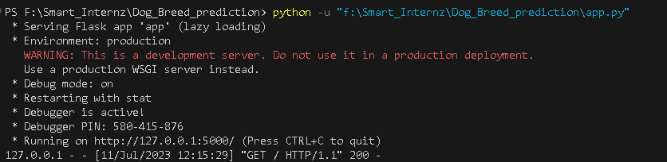
Navigate to the localhost (http://127.0.0.1:5000/)where you can view your web page.
FINAL OUTPUT:
Output 1:
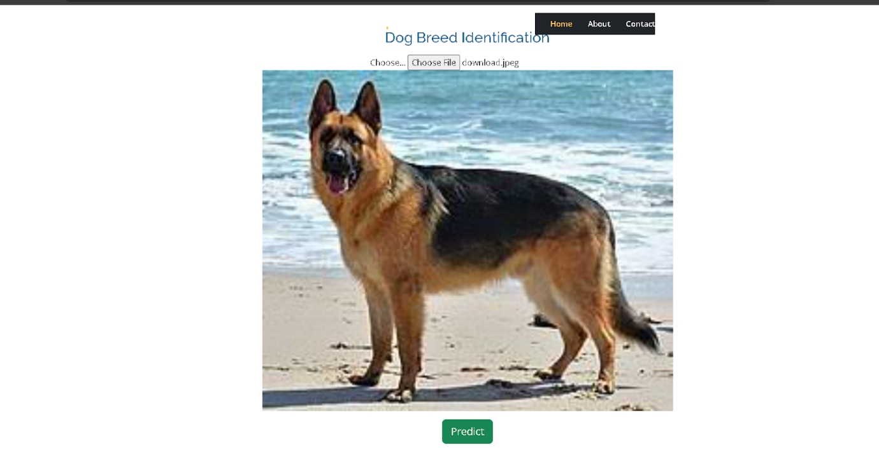
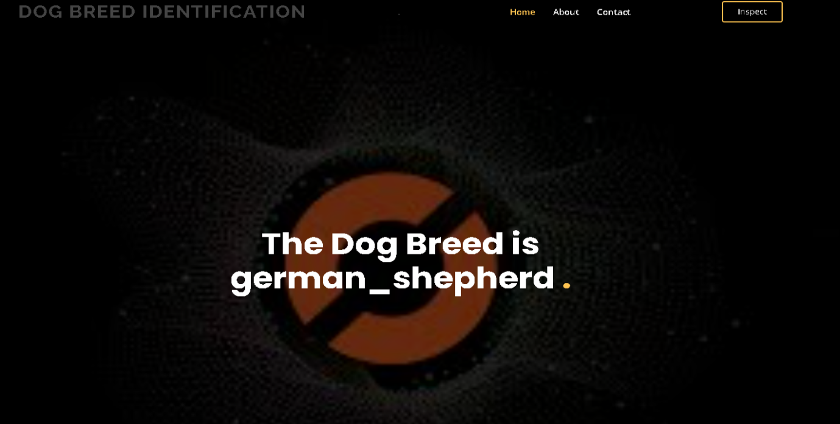
Output 2:

